TARS
Delivery System
Online Post Office Management

User Guide

November 15, 2010

This is to certify that

Mr. Kawai
Ms. Sato

Has successfully Designed & Developed
TARS Delivery System online application

Submitted by: Masanori Kawai, Eri Sato

Date of Issue: 15/November/2010

Authorized Signature:______________

TARS
Delivery System
Online Post Office Management

Welcome to TARS Delivery System!
This system is for Online Post Office Management.
This user guide will introduce you to our service
and help you get smooth operations.

Contents

- Introduction
- Installation
- User Types
- User
- Employee
- Administrator

Introduction

TARS Delivery System is a online application which enable you to manage delivery easily. You can easily refer to records of orders and overcome discrepancies in your project.

Installation

Expanding the submitted zip file, the below files will appear.

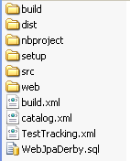

- Executing WebJpaDerby.sql in NetBeans

- 1. Open WebJpaDerby.sql from Open File in menu.
- 2. Select “jdbc:derby://localhost:1527/sample[app on APP]” from connection.
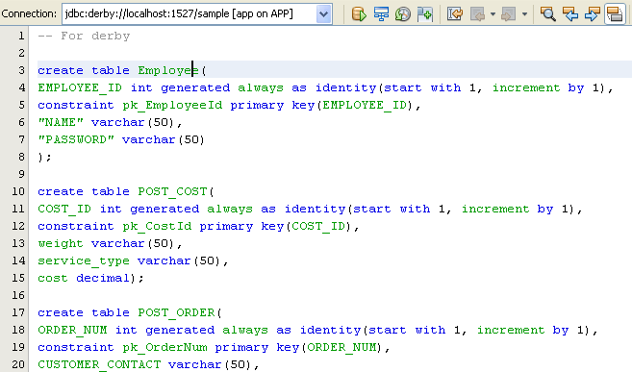
2

- 3. Click add Execute SQL statements.

- Deploy war files in Glassfish

- Open the WebJpa the project file in NetBeans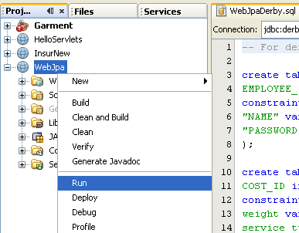.

- Click right button on the mouse, please select run.

User Types

TARS Delivery System has three types of users:

- User
- Employee
- Administrator

User

The user is limited to the following:
- Creating orders for customers
- Calculating total charge for advertisements automatically based on the parameter provided by the System Administer.
- Reference records of customer orders.

Employee

The user is limited to the following:
- Creating orders for customers
- Calculating total charge for advertisements automatically based on the parameter provided by the System Administer.
- Reference records of customer orders.

Administrator

The Administrator can use all function within the software, as well as manage the following:
- Creating, editing and deleting Employee accounts
- Editing and deleting orders
- Editing the price of advertisements by setting the parameters of content type, size type and page type.

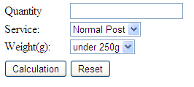
User
Calculation

When you access to TARS Delivery System, Calculation window will be displayed at first.

- Enter Quantity.

- Select Service.

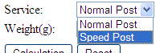

- Select Weight (g).

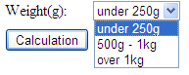

- Click Calculation to see the result of calculation.

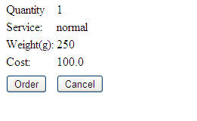
- Click Order or Cancel.

Employee

Logging in

To login to TARS Delivery System as Employee, select Employee on the left side window. Now you can see the login window on the right side. Enter Employee Name and Password.

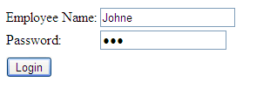
You can see the window as below.

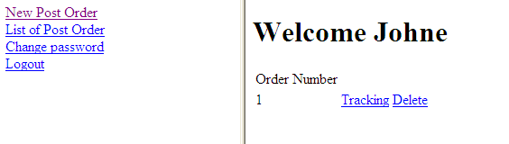

To see the tracking window click Tracking on the right side window.

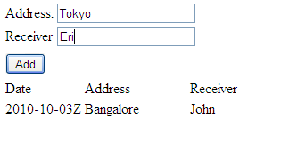
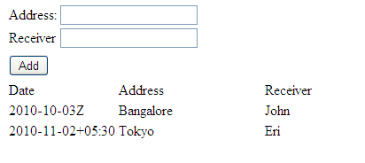

Administrator

Logging in

To login to TARS Delivery System as Employee, select Employee on the left side window. Now you can see the login window on the right side. Enter Employee Name and Password.

